SK SEMERAH PADI HOMEWORK MANAGEMENT SYSTEM

RAIHAN AFIQAH BINTI LATIP

AI200096

BACHELOR OF COMPUTER SCIENCE (SOFTWARE ENGINEERING) WITH HONOURS

UNIVERSITI TUN HUSSEIN ONN MALAYSIA

**UNIVERSITI TUN HUSSEIN ONN MALAYSIA**

**PENGESAHAN STATUS LAPORAN PROJEK SARJANA MUDA**

**SEKOLAH SEMERAH PADI HOMEWORK MANAGEMENT SYSTEM**

**ACADEMIC SESSION: 2022/2023**

I, **RAIHAN AFIQAH BINTI LATIP**, agree to allow this Undergraduate Project Report to be kept at the Library under the following terms:

1. This Undergraduate Project Report is the property of the Universiti Tun Hussein Onn Malaysia.
2. The library has the right to make copies for educational purposes only.
3. The library is allowed to make copies of this report for educational exchange between higher educational institutions.
4. ** Please Mark (√)

|  |  |  |
| --- | --- | --- |
|  | CONFIDENTIAL | (Contains information of high security or of great importance to Malaysia as STIPULATED under the OFFICIAL SECRET ACT 1972) |
|  |
|  |  |
|  |  |  |
|  | RESTRICTED | (Contains restricted information as determined by the  Organization/institution where research was conducted) |
|  |
|  |  |  |
|  |  |  |
|  | FREE ACCESS |  |
|  |  |

|  |  |  |  |
| --- | --- | --- | --- |
|  | |  | Approved by, |
|  | |  |  |
| (WRITER’S SIGNATURE) | |  | (SUPERVISOR’S SIGNATURE) |
|  | |  |  |
| NO 433, LOT 787,  KPG. SEMERAH PADI,  JALAN BANGAU,  93050, KUCHING,  SARAWAK | |  |  |
| Date: _________________________ | |  | Date: _________________________ |
| Note: | | | |
| ** | If this Undergraduate Project Report is classified as CONFIDENTIAL or  RESTRICTED, please attach the letter from the relevant authority/organization stating reasons and duration for such classifications. | | |

SK SEMERAH PADI HOMEWORK MANAGEMENT SYSTEM

RAIHAN AFIQAH BINTI LATIP

A project report submitted in partial

fulfilment of the requirement for the award of the

Degree of Bachelor of Computer Science (Software Engineering) with Honours

Fakulti Sains Komputer dan Teknologi Maklumat

Universiti Tun Hussein Onn Malaysia

January 2023

I hereby declare that the work in this project report is my own except for quotations and summaries which have been duly acknowledged

|  |  |  |
| --- | --- | --- |
| Student | : | ...................................................................... |
|  |  | RAIHAN AFIQAH BINTI LATIP |
| Date | : | ...................................................................... |

|  |  |  |
| --- | --- | --- |
| Supervisor | : | ..................................................................... |
|  |  | DR. NORAINI BINTI IBRAHIM |

# DEDICATION

For my beloved parents

# ACKNOWLEDGEMENT

First and foremost, I would like to thank the almighty god (Allah S.W.T) for blessing me with good health throughout the completion of the project. He provided me with all the strength to complete this project.

I wish to express my sincere gratitude to my supervisor, Dr. Noraini Binti Ibrahim, for the support given to complete the project. Her patience, insightful comments, and suggestions, advice, and ideas have greatly helped in writing this report.

In addition, I would also thank my parents and family members who always encourage and support all my decisions. Finally, I would also like to thank all academicians in the Faculty of Computer Science and Information Technology and my friends who have helped me with the compilation of the report.

# ABSTRACT

Sekolah Kebangsaan Semerah Padi Homework Management System (SK SP HMS) is a web-based system which mainly acts as a platform for teachers to add and grade homework and for students to submit their homework. The system aims to improve the weaknesses found in the existing process in which the student needs to submit their physical book to the teacher and the teacher needs to review and return the book to the student after they review it. Meanwhile, a scrum model was used to develop this project by using the object-oriented approach. The programming languages used are Hypertext Preprocessor(PHP) and HyperText Mark-up language (HTML). This system is built to assist the students and teachers to complete their task more efficiently and assist the parents to monitor their child's progress.

# ABSTRAK

Sekolah Kebangsaan Semerah Padi Homework Management System (SK SP HMS) adalah aplikasi berasaskan web yang berfungsi sebagai platform untuk guru memberi kerja rumah dan untuk pelajar menghantar kerja rumah mereka. Sistem ini bertujuan ntuk memperbaiki kelemahan yang terdapat dalam proses sedia ada di mana pelajar perlu menyerahkan buku fizikal mereka kepada guru dan guru perlu menyemak dan memulangkan buku tersebut kepada pelejar selepas mereka menyemaknya. Sementara itu, odel scrum digunakan untuk membangunkan projek ini dengan menggunakan pendekatan berorientasikan objek. Bahasa pengaturcaraan yang digunakan ialah Hypertext Preprocessor (PHP) dan HyperText Mark-up language (HTML). Sistem ini dibina untuk membantu pelajar dan guru menyelesaikan tugas mereka dengan lebih cekap dan membantu ibu bapa memantau kemajuan anak mereka.

# CONTENTS

TITLE i

DEDICATION iii

ACKNOWLEDGEMENT iv

ABSTRACT v

ABSTRAK vi

CONTENTS vii

LIST OF FIGURES x

LIST OF TABLES xi

LIST OF APPENDIX xii

1 CHAPTER 1 1

1.1 Project Background 1

1.2 Problem Statement 2

1.3 Objective 3

1.4 Scope 3

1.5 Expected Result 4

1.6 Project Significance 4

1.7 Chapter Summary 5

1.8 Report Organization 5

2 CHAPTER 2 6

2.1 Introduction 6

2.2 Domain background 6

2.3 Web-based application 7

2.3.1 Homework management system (HMS) 7

2.4 Existing system of SK SP Homework Management System 8

2.5 Study of Existing Related Systems 9

2.5.1 Frog VLE 10

2.5.2 Google Classroom 11

2.5.3 Academic Online Resources (AUTHOR - UTHM) 12

2.6 Comparison with the Existing Systems 13

2.7 Chapter Summary 15

3 CHAPTER 3 16

3.1 Introduction 16

3.2 Methodology of proposed system 16

3.2.1 Pre-sprint phase 17

3.2.2 Development phase 18

3.2.3 Post-sprint phase 19

3.3 Project planning 20

3.4 Chapter Summary 20

4 CHAPTER 4 21

4.1 Introduction 21

4.2 System Requirements analysis 21

4.2.1 Functional Requirement and Non-Functional Requirement Analysis 22

4.2.2 User Requirement Analysis 23

4.2.3 Software and Hardware Requirement 24

4.3 System analysis 25

4.3.1 Use Case Diagram 25

4.3.2 Use Case Specification 26

4.3.2 Requirement Traceability Matrix 30

4.3.3 Class Diagram 32

4.4 System design 33

4.4.1 Interface design 33

4.5 Chapter Summary 35

REFERENCES 36

# LIST OF FIGURES

Figure 2.1:Activity diagram for the existing system 9

Figure 2.2:Frog VLE main page [12] 11

Figure 2.3:Google Classroom main page [16] 12

Figure 2.4:AUTHOR-UTHM main page 13

Figure 3.1: Scrum approach of the proposed HMS development project 17

Figure 4.1: Use case diagram for SK SP HMS 26

Figure 4.2: Use case Login 27

Figure 4.3: Use case Register user 27

Figure 4.4: Use case Manage user information 28

Figure 4.5: Use case Manage homework 28

Figure 4.6: Use case Submit homework 29

Figure 4.7: Use case Record grade 29

Figure 4.8: Use case Generate report 30

Figure 4.9: Class diagram 32

[Figure 4.10: Interface for login and register 33](https://d.docs.live.net/670cacaa020e9cb6/Documents/FYP.docx#_Toc124316035)

[Figure 4.11: Wireframe for the other module 34](https://d.docs.live.net/670cacaa020e9cb6/Documents/FYP.docx#_Toc124316036)

# LIST OF TABLES

Table 1.1: Application Modules 3

Table 2.1:System comparison table 13

Table 4.1:System functional module for SK SP HMS 21

Table 4.2: Functional requirements of SK SP HMS 22

Table 4.3: Non-functional requirements of SK SP HMS 23

Table 4.4: User requirements of SK SP HMS 23

Table 4.5: Hardware requirements for SK SP HMS 24

Table 4.6: Software requirements for SK SP HMS 24

Table 4.7: Requirements traceability matrix 31

# 

# LIST OF APPENDIX

APPENDIX A **(Gantt Chart*.*** 39

APPENDIX B**(Use Case Specification*.*** 40

# CHAPTER 1

**INTRODUCTION**

## Project Background

Homework is an important thing for students. It is one of the methods used to test the student’s level of understanding. Homework also helps students to build up their thinking and problem-solving skills. Frequently homework management system used in Malaysia is still done traditionally. The student is required to submit their book to their teacher and the teacher needs to review them after it has been submitted.

As the world modernized, people started to adapt with all the technology which also included the student. Students nowadays know more about the usage of technology. According to a research [1] made for primary school students in Tiram zone, students primarily used tablets (9.8%), laptops (16.2%), and smartphones (57.4%) of these three types of devices. This shows that the students have access to the devices.

With access to technology, the student must be able to learn the usage of a web-based application. It is a platform that requires a web browser to run the application. UTHM academic online resources (AUTHOR-UTHM) [2] is an example of the system that used the web-based application. It is accessible to all devices with web browser which make it convenient for the user since they were not required to install the application and use their storage.

Sekolah Kebangsaan Semerah Padi (SK SP) is situated in Petra Jaya, Kuching, Sarawak. The homework management system for this school is still done manually. It is not convenient for the user. For this project a homework management system (HMS) will be developed to provide users with a platform to manage the homework through the system. For the system to work, users need to login into the system first to access the system. With the proposed homework management system, it should be able to facilitate users to manage the homework.

## Problem Statement

At SK SP, the current existing process requires the student to submit their book physically to their teacher. Usually, teachers will update the homework daily in the class’s WhatsApp group to remind the student in case they forget. After they submit the homework, the teacher will mark their book and return it to them. Subsequently, the parent may check their child’s book to know whether their child already completed their homework or not.

The problem statements of the existing system are:

It is difficult for parents to monitor their child’s homework progress. It is parents’ responsibility to monitor their child’s homework progress. However, the existing system is less convenient since it requires parents to check their child’s book to know their homework progress. This makes it harder for the parents to monitor their child’s homework progress.

Next, it is difficult for students to manage the homework. These days, the school has created a schedule for students that is very packed with extra classes and co-curriculum. This issue may cause the student to forget about the homework given by their teacher. The existing system requires the student to check the group WhatsApp for homework if they forget about it. This makes it more challenging to manage their homework.

Aside from that, it is challenging for teachers to manage student homework. Managing all the student homework can be difficult especially with the existence of “Pentaksiran Bilik Darjah (PBD)”. This is due to no proper system to store the data of students’ homework. Usually, teachers will only record it in the book. There will always be chances that the data will be lost, and teachers cannot refer the data to evaluate students.

## Objective

Three objectives of the SK SP HMS are:

i) To design a homework management system using an object-oriented approach

ii) To develop a homework management system using Android technology

iii) To test and implement the developed homework management system

## Scope

The system stakeholders which will be using the system are the admin, the teacher, the student, and parents. The organization chosen for this project is SK SP. This project will focus on class one tulip for Mathematic and English subjects. All the users were required to login into the system to have access to the features. The platform for the system will be using a web-based application. All the modules are shown in Table 1.1.

Table .: Application Modules

|  |  |
| --- | --- |
| Module | Description |
| Login | For login, username and password needed to access the system |
| Register user | The admin should register the student, parent, and teacher to allow them to login. |
| Manage user information | The admin should manage the student, parent, and teacher from time to time if there are changes, for example, subject and class. |
| Manage homework | The teacher can add the homework by uploading files through the system |
| Record grade | The teacher can grade the homework after the student submits homework. The student and parent should be able to view the grade after the grade were uploaded. |
| Submit homework | The system will have options either to submit the homework online or offline, but the student needs to follow their teacher instruction either to submit through the system or offline. Teacher will update it according to their lesson plan. |
| Generate report | The system will generate reports for grade if the user requests the report. |

## Expected Result

When this project is completed, the system should be able to help the teacher to monitor the homework given to the student and the parent should be able to monitor their child’s homework progress through the system. The student should also be able to track their own progress.

Secondly, the system should be able to help students to manage their homework by having a list of homework features. Parents and students should be able to view the homework uploaded by the teacher that needed to be done. The teacher will include the submission method according to the lesson plan.

Thirdly, the system should be able to help teachers manage student homework by allowing the teacher to view all records of the homework submitted and the mark graded to the student. The system also should be able to let teachers detect the student that had not submitted their homework from the record of homework submitted.

## Project Significance

The first project’s significance is to improve the student’s education well-being. When the parent can monitor the child’s homework progress, they will be able to help and guide their child with their weaknesses if they cannot complete the homework.

Secondly, the project’s significance is to develop students’ time management skills. When the student can manage their homework efficiently, they will be able to plan their time wisely and allocate their time for homework and other stuff.

Thirdly, the project’s significance is to have a conducive learning environment. When the teacher can manage their student homework, they would not feel overwhelmed hence their mood will improve to teach their students.

## Chapter Summary

In chapter 1, there will be the project background where the details regarding the project will be explained. There will also be a problem statement which explains the issue of the existing system. The objective and scope of the project will also be included in chapter 1. The scope explained about the users involved, limitation of the project, platform used and all the modules in the system. The expected result for the project and the significance also will be discussed in chapter 1.

## Report Organization

The report's remaining sections are arranged as follows. The terms and concepts that are necessary, the current system, and a comparison of the current and proposed systems are covered in Chapter 2. Chapter 3 studies the methodology chosen for the project in which the timeline will be used throughout the project. Chapter 5 consists of the analysis and design where all the diagram such as use case and class diagram. Lastly for Chapter 6, it will be the conclusion of the whole project.

# CHAPTER 2

**LITERATURE REVIEW**

## Introduction

This chapter discusses the literature review for the system and the current system that is being used by the school. It is done to gather data related to the proposed system. The introduction will be covered in Section 2.1. The background of the domain will then be covered in Section 2.2, and web-based applications will be covered in Section 2.3. Furthermore, Section 2.4 will go into more detail on the current system in use. In addition, Section 2.5 had evaluated and compared the developed system with three other existing systems. The comparison of the existing and proposed systems is made to identify the system's strengths and weaknesses, which may then be used as a guide to create an effective system. In Section 2.7, the chapter's summary was finally explained.

## Domain background

SK SP is located at Petra Jaya, Kuching, Sarawak [3]. Currently, the headmaster of the SK SP is Encik Jefri bin Said. The school consists of standard 1 until standard 6 students. There are 5 classes which are Tulip, Hibiscus, Orchid, Rose, and Lily. Usually in each class, there will be around 30 students.

Increasing numbers of students add more responsibility to management to manage all their data, which includes their students’ homework data. It is necessary to keep the students’ homework data recorded to ease the evaluation process for the teacher. It will also be beneficial for students if they want to review their homework to improve their study progress.

## Web-based application

A web-based application may be accessed through the internet rather than being stored in a device's memory. Most of the time web-based applications run inside a web browser. In the last ten years, there has been a significant change in the state of web application development which may be caused by the improvement of greater bandwidth [4]. Few examples of web applications are Gmail, Facebook, Instagram, and Twitter [5].

The performance, reliability and quality of web-based applications are important things that should be considered. The common issues of web application are web site crash and security breaches [6]. It should be handled and managed to avoid bad user experience. Some advantages of using web-based applications are it is always up to date since the update is automated and it is accessible anywhere with internet access.

### Homework management system (HMS)

In many fields of study such as chemistry, physics and mathematics, web-based homework systems have replaced traditional paper-and-pencil homework [7]. People are adapting with technology and the students nowadays prefers to do things digitally including submitting homework.

There are a lot of homework management systems available. Some LMS use web-based applications, and some may use mobile applications or both. For example, Google Classroom [8] is available for the Chrome operating system (Chrome OS) and Android. The proposed system will be developed using web-based applications for easier access for the user.

## Existing system of SK SP Homework Management System

In the existing process for SK SP, its homework management system is still done traditionally. For the student, they need to submit their homework when the teacher asks for them. Students need to be aware of the homework given and the due date when the teacher briefs them about it. Sometime the teacher will remind and list the homework in the class WhatsApp group. For the teacher they can only grade their student if the students submit their homework. It is less efficient to detect the students that had not submitted their homework since there are a lot of students. While the parents can only monitor their child’s homework progress if they check their child’s book or ask the homeroom teacher about their progress. Figure 1 shows the activity diagram for the existing process of SK SP HMS.

Figure .:Activity diagram for the existing system

## Study of Existing Related Systems

Three existing systems are investigated through each system characteristics to support the study of the proposed system. The three existing systems selected are Frog VLE, Google Classroom and Author (UTHM).

### Frog VLE

Frog virtual learning environment (Frog VLE) [9] is a web-based application learning management system that can be used to centralize the administration into a single system which is very convenient. Not only it can be used as a homework system, but it can also be used as a discussion platform [10]. Through a single platform, the user can access a lot of features. For example, the student can access documents anywhere with internet connection, communicate with the teacher, and submit homework through Frog VLE. It makes the user’s life easier and reduces the time it takes to use more than one system. It can be used by the staff, students, governors, and also the parents according to the setting set by the organization. Frog VLE is one of the platforms used in high school in Malaysia back in 2016.

Some of the tasks that can be done through Frog VLE [11] are the teachers may add homework, quizzes, and mark. While for the student, they should be able to submit their homework and check the mark obtained that the teacher had uploaded. In addition, for the parents, they can communicate with the teachers and the organization can organize the school academic calendar and post the notice on Frog VLE. The platform is accessible anywhere as long as the internet can be connected. The learning curve is reduced because it is a web-based application that mimics a real-world process and users are already familiar with its features. The system’s aim is mainly to make the teacher and student life easier and at the same time to improve the learning process.

Frog VLE is related to the proposed system since some of the functions are similar to the proposed system. For example, it uses web-based applications, and the platform can be used as the homework management system. It can be used to make comparisons to improve the proposed system. There are a lot of things that can be learned from Frog VLE. One of the features of Frog VLE that can be applied to the proposed system is it can allow the parents to communicate with the teacher. It is one of the functions that can be implemented. Figure 1.0 shows the main page of Frog VLE.

Figure .:Frog VLE main page [12]

### Google Classroom

Google Classroom [13] is a web-based application that can be used as a platform for submitting homework. It is an acknowledged platform, and one of the greatest online learning and teaching platforms [14]. The system is beneficial and efficient since it offers new challenges for continuing education in various ways for teachers and learners. Everyone has access to it as long as they can connect to the internet. Google Classroom is said to have received 30 million assignments from teachers and students in the first six months of operation. Google Classroom offers scheduling flexibility, does not require travel fees, and can be accessed by anyone.

The functions provided [15] are for the teacher they can create and manage classes, assignments, and grades online without paper, add materials to your assignments, and use class stream to post announcements. The student may keep track of their homework and turn in assignments, as well as check for originality, receive feedback, and receive grades. They can also share resources, chat in the class stream, or through email. Parents can see announcements and activities and receive an email summary of their child's work. The final option for administrators is to define user permissions, safeguard data, create classes and rosters, add, or remove students, and set up classes.

It is related to the proposed system since some of the functions are like the proposed system. For example, it uses web-based applications, and the platform used as homework management system. It can be used to make comparisons to improve the proposed system. There are a lot of things that can be learned from Google Classroom. A feature of Google Classroom that can be applied to the proposed system is the guardians they may get an email summary of the student’s work. Figure 2.0 shows the main page of Google Classroom. In Figure 2.0 it shows the interface of the google classroom without any active class. Users need to have an active email address to connect with the google classroom. Only then the user can join the class using code or link from the instructor.

Figure .:Google Classroom main page [16]

### Academic Online Resources (AUTHOR - UTHM)

AUTHOR-UTHM [17] is a web-based LMS, a platform that allows lecturers to manage their courses and exchange information with students online. The main features in AUTHOR-UTHM are announcements, messaging system, files sharing, multimedia embedded course materials, educational links, forums, video conferencing, online quizzes, and assignments. The advantage of AUTHOR-UTHM that can be applied to the proposed system is video conferencing. It is one of the functions that can be considered to be implemented.

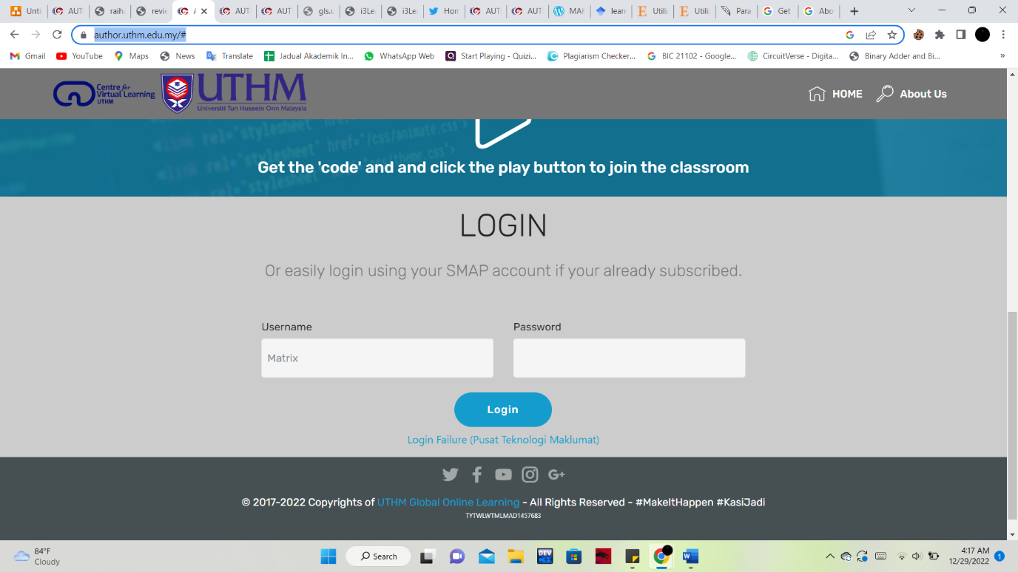

Figure .:AUTHOR-UTHM main page

## Comparison with the Existing Systems

The features between the two existing systems and the proposed system are compared in Table 2 as shown below. The proposed system does not have announcement and communicate with teacher features.

Table .:System comparison table

|  |  |  |  |  |
| --- | --- | --- | --- | --- |
| **Features/System** | **Frog VLE** | **Google Classroom** | **AUTHOR-UTHM** | **SK SP HMS** |
| Login | User need to input Yes ID/NRIC and password to login into the system | User need to login with Google Account to login into the system | User need to input username and password to login into the system | User need to input username and password to login into the system |
| Register user | The admin need to register the user to allow them login into the system | User need to have Google Account to login into the system | The admin need to activate student’s Author account to login into system | The admin need to register the user to allow them login into the system |
| Manage user information | The admin may add, edit, and delete the user information | The instructor may add, edit, and delete the user information | The admin may add, edit, and delete the user information | The admin may add, edit, and delete the user information |
| Add  Homework | Instructor may click on the +(plus) button in FrogBar to add homework | The instructor may click on the “ + Create” in classwork section button to add homework | The lecturer may click “Add project” to add homework | The teacher may click “Add” button to add homework |
| Submit Homework | The student may drop or drag the file they want to upload and click “hand-in” button to submit homework | The student may upload google drive, link, or file and click “turn in”to submit homework | The student may click browse to submit. They can  upload up to 100MByte per-file | The student may upload the file (.doc/.jpeg) |
| Grade Homework | The instructor may mark the homework virtually and the student should be able to view it after the instructor upload the grade | The instructor will upload the mark on the classwork section and the student should be able to view it after the instructor upload the grade | The lecturer will upload the mark on the mark section and the student should be able to view it after the instructor upload the grade | Teacher, should be able to mark the student and upload the grade so that the student and parent may view the grade |
| Generate report | Markbook is the latest feature in Frog VLE that easily allows instructors to review classroom progress for online and offline assignments across the year. | Teachers can create the [student Progress Reports](https://docs.google.com/document/d/1toZ5kzJBK6X5lZrYLALJsBJJRU_zUn9F-2VoTVLd0gk/edit?usp=drive_web&ouid=103849804399107067156) based on Google Classroom activity across all classes connected in Schoolytics and over any date range. The teacher may share the report with the student. | This feature is not available | Teacher, the student, and the parent may view the grade report |
| Announcement | This feature is not available | The instructor may post an announcement on the steam section | The lecturer may put an announcement on stream section | This feature is not available |
| Communicate with teacher | The system can be used to communicate with teachers, students, and parents | On the stream section there is a comment feature which allow student in the class to communicate with lecturer | On the stream section there is a reply feature which allow student to communicate with lecturer | This feature is not available |

Based on table 1, the proposed system has all of the features listed except for announcements and communicate with teacher features.

## Chapter Summary

As a conclusion, Chapter 2 has described the background of case study. The study among three existing systems which are Frog VLE, Google Classroom and AUTHOR and the proposed system which SK SP HMS is also conducted. This proposed system is to make it convenient for the target user and literature review done is to validate the proposed system. The next chapter, which is Chapter 3, will be explaining about the methodology model used for this project.

# CHAPTER 3

**METHODOLOGY**

## Introduction

In this section, the methodology used to develop SK SP homework management system will be discussed. A software development methodology is used during the analysis, planning, design, development, testing, setup, and maintenance of a software product [18]. Different methodologies would have different processes and ways of implementation. In this project, the chosen methodology is the scrum approach.

## Methodology of proposed system

Scrum approach is a framework aids in organization and management job [19]. The process is divided into several main parts. Sprint is the fundamental unit of scrum. Sprint usually lasts between 2 and 4 weeks. Planning for the primary system features, implementing the plan, testing, and reviewing the feature are all activities that will be covered during the sprint process. Up until the intended result is publicly released, the cycle will be repeated. The pre-sprint phase, development phase, and post-sprint phase are the three phases that make up the development of HMS inside the scrum framework. In Figure 5, the flow is displayed.  
  
  
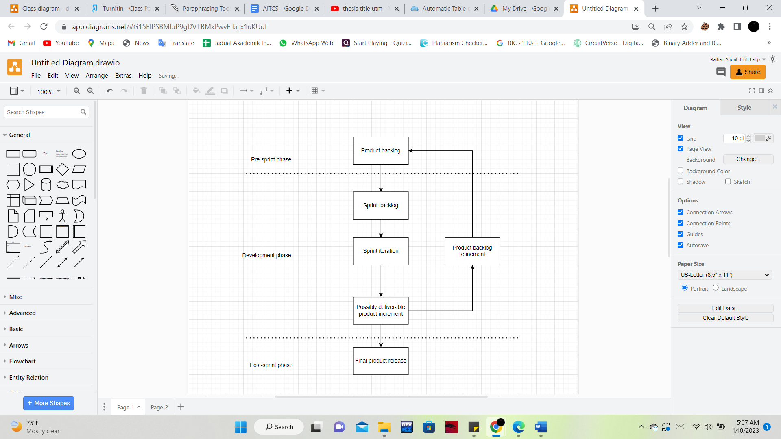

Figure .: Scrum approach of the proposed HMS development project

### Pre-sprint phase

The HMS development life cycle begins with the pre-sprint phase. The focus for this phase is the project backlog.

#### Project backlog

The first stage in development is to create a project backlog. Product backlog [20] is a list of HMS features that need to be implemented during the development process. It may contain the following information: ID, priority, backlog item, body of features, demonstration, kind of backlog item, estimated development time in weeks, and its related status. Each item is referred to as a user story and is listed according to priority. User stories are often defined according to the pattern ‘As a <User>, I want to <Have> so that <Benefit>’. The pattern makes it easier for developers or project owners to understand.

The features required for the completion of backlog items are discussed in the features body. The outcomes of the proposed HMS are revealed in the demonstration. The project item is expected to take two to four weeks to complete. Finally, while selecting a status, the project owner must identify if a backlog item is in a ready, running, or completed state. Backlog items will be added, updated, and removed as work progresses after they have been modified. Later, the priority might be altered. Based on the preliminary list, any bug occurrence can also be found.

### Development phase

The development phase is the second stage of the scrum framework. The entire project backlog from the pre-sprint phase will be received at this stage. Based on the expected outcome, the HMS should be developable. The four stages of the sprint backlog, sprint iteration, possibly deliverable product increment, and product backlog refinement will be used to structure development. The process will go on indefinitely until HMS is finished.

#### Sprint backlog

The sprint backlog must be first created using the chosen project backlog. The list of user stories from the product backlog that have been chosen for the upcoming sprint is the sprint backlog [21]. The project backlog's features will all be combined into a single sprint task. The whole estimated day is converted to the estimated week in the project backlog. Similar to the pre-sprint phase, the backlog item's state is chosen to indicate to the project owner whether it is ready, running, or complete. Therefore, sprint planning is required to determine how long, in days or hours, it will take to finish a single sprint assignment. A product backlog's expected days should not be exceeded by the estimated days for all of the tasks. The flexibility of task adjustment allows the project owner to release HMS version more frequently.

#### Sprint iteration

For this step it is associated with the execution of the tasks for HMS completion. Once the steps begin, the sprint task would not be able to have any changes. It needs to wait until the sprint is completed. However, the sprint may finish prematurely if the project backlog is altered or it is determined that there are issues that are challenging to solve. If the task on the sprint task is activated, the status will change from "Ready" to "Running status" in the status selection, which serves as a task board. Even once a task is finished, it is not regarded as finished. It must first be tested, and once the test is over, the status will change from "Testing" to "Done”.

#### Possibly deliverable product increment

All sprint iteration step completion will produce the creation of a new version of the HMS called possibly deliverable product increment. The product produced could be demonstrated to the end users. The framework will either go on to the last post-sprint phase or refine the product backlog if there are no more items in the project backlog.

#### Product backlog refinement

This stage compiles the overall outcomes of the demonstrated HMS and its sprint performance for further analysis. The decisions on further project changes will be decided by the project owner. Not only that, but the project owner also needs to decide on a method for development process improvement.

### Post-sprint phase

The HMS development life cycle ends with this stage. Once the previous development phase was complete, this phase began. The developed HMS should be prepared for release at this stage. Next steps in this phase include retrospective analysis, knowledge, experience, and created tools which will be used for documentation.

#### Final product release

The compilation of code, tools, and documentation makes up the finished product release. The complete HMS will be made available in this step.

## Project planning

For managing and organising throughout all of the HMS development life cycles in this project, GanttProject is used to build the Gantt chart and the scrum documentation.

## Chapter Summary

In this chapter, the methodology used to develop SK SP Homework Management System is introduced. Scrum method is used to develop the system as it provides iterative development processes. Also, all the phases conducted in the scrum model are discussed in a detailed way.

# CHAPTER 4

**ANALYSIS AND DESIGN**

## Introduction

This chapter discusses the outcome of analysis and design of the SK SP HMS. In Section 4.2, it discusses analysis of system requirements. Section 4.3 shows the system analysis, while section 4.4 is the system design.

## System Requirements analysis

A structured or organized approach for identifying the right set of resources to satisfy system needs and requirements is called system requirement analysis [22]. It covers user requirements, system requirements, and functional and non-functional requirements. In table 4.1 functional modules provided in SK SP HMS were listed.

Table .:System functional module for SK SP HMS

|  |  |  |  |
| --- | --- | --- | --- |
| No. | Module | Function | User |
| 1. | Login module | To manage registered user (admin, teacher, parent, student) login into the system | Admin, Teacher, Student, Parent |
| 2. | Register user module | To manage user registration (teacher, parent, student) into the system | Admin |
| 3. | Manage user information module | For user to:  Add, edit, delete user information that are in the system database | Admin |
| 4. | Manage homework module | For user to:  Add, edit, delete homework that are in the system database | Teacher |
| 5. | Submit homework module | For user to:  Add, edit, delete homework that are in the system database | Student |
| 6. | Record grade module | For user to:  Add, edit, delete grade that are in the system database  For user to:  View grade | Teacher  Parent, Student |
| 7. | Generate report module | Generate grade summary report | Teacher, Parent, Student |

### Functional Requirement and Non-Functional Requirement Analysis

Functional requirements are used to describe the function of the developed system. Table 4.2 shows the functional requirements of the proposed system.

Table .: Functional requirements of SK SP HMS

|  |  |  |
| --- | --- | --- |
| No. | Module | Function |
| 1. | Login module | * The system should allow user to login into the system using registered username and password * The system should allow only registered user to login into the system * The system should redirect user to respective home page upon successful login |
| 2. | Register user module | * The system should allow admin to register new user into the system * The system should be able to store the registered user information in the database |
| 3. | Manage user information module | * The system should allow admin to add user information * The system should allow admin to edit user information * The system should allow admin to delete user information |
| 4. | Manage homework module | * The system should allow teacher to add homework * The system should allow teacher to edit homework * The system should allow teacher to delete homework |
| 5. | Submit homework module | * The system should allow student to submit homework * The system should be able to allow student to delete submitted homework |
| 6. | Record grade module | * The system should allow teacher to add grade * The system should allow teacher to edit grade * The system should allow teacher to delete grade * The system should allow student and parent to view grade |
| 7. | Generate report module | * The system should allow teacher, parent, and student to generate report |

Non- functional requirements are typically challenging to describe since they lack specific criteria for satisfaction [23]. It is used to describe a system’s operation capabilities. Table 4.3 shows the non-functional requirements of the developed system.

Table .: Non-functional requirements of SK SP HMS

|  |  |  |
| --- | --- | --- |
| No. | Requirements | Description |
| 1. | Security | System that is developed must have high security characteristic to keep the personal information user |
| 2. | Performance | System that is developed should be able to be access all the time |
| 3. | Operational | The developed system should be able to generate report needed within two minutes |

### User Requirement Analysis

User requirements are used to specify what the user expects the system’s functionality to accomplish. Table 4.4 shows the user requirements of the developed system

Table .: User requirements of SK SP HMS

|  |  |
| --- | --- |
| No. | User Requirements |
| 1. | Users need to login into the system to use system functionality |
| 2. | Unregistered user cannot access to the system |
| 3. | Unregistered need to be registered by the admin to login into the login |
| 4. | Admin can register user into the system |
| 5. | Admin can manage the user information |
| 6. | Teacher can add homework |
| 7. | Teacher can edit and delete homework |
| 8. | Student can submit homework |
| 9. | Student can delete submitted homework |
| 10. | Teacher can add, edit, delete, grade |
| 11. | Student and teacher can view grade |
| 12. | Teacher, Student and Parent can generate |

### Software and Hardware Requirement

Software and hardware requirement is the hardware and software required to develop the proposed system. Table 4.5 list the hardware requirements and Table 4.6 shows the software requirements of the developed system

Table .: Hardware requirements for SK SP HMS

|  |  |
| --- | --- |
| Specification of hardware | |
| Processor | At least dual core, 2.0 GHz or higher |
| Display | Recommended 1080 x 1920 |
| Memory | 4 GB RAM or higher |
| Internet Connection | At least 2MB per second |
| Storage | 100 GB or higher |
| Laptop | Personal Laptop |

Table .: Software requirements for SK SP HMS

|  |  |
| --- | --- |
| Type of software | Specification of software |
| Operation system | Windows 10 |
| Database | MySQL |
| Web server | XAMPP |
| Gantt Chart software | GanttProject |
| Diagram software | Draw.io |

## System analysis

System analysis and design is [24] a process to construct high quality information systems. In this part the analysis and design are discussed. The use case, activity diagram, sequence diagram and class diagram of this project are included in this chapter. A brief explanation will be discussed for each diagram.

### Use Case Diagram

Behavior diagram in UML is portrayed using a use case diagram [25]. It can be used to describe the functional requirements of the proposed system. Figure 4.1 shows all the modules available in the system. 7 modules that are available in the system are login, register user, manage user information, manage homework, record grade, submit homework, and generate report.

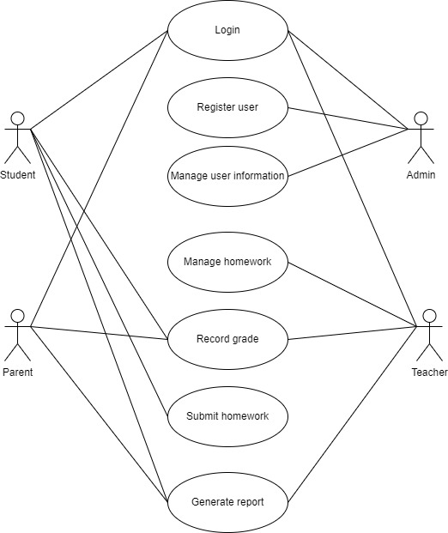

Figure .: Use case diagram for SK SP HMS

The use case diagram above shows the actor involved in the system. For example, for login the actor involved are all the user which are student, admin, parent, and teacher. It helps to illustrate the flow of the system.

### Use Case Specification

Use case specification is [26] used to provide textual detail for a use case. There will be 7 use case specifications since there are 7 modules. All the use case specifications will be attached in appendix b.

#### **Use Case Login (SRS_REQ_100)**

Login modules is used by all users. Each user needs to login into the system to access the features in the system. The unregistered user cannot access and login into the system.

|  |
| --- |
|  |

Figure .: Use case Login

#### **Use Case Register user (SRS_REQ_200)**

The register user module is used by the admin. The admin needs to register all the users first for them to login into the system.

|  |
| --- |
|  |

Figure .: Use case Register user

#### **Use Case Manage user information (SRS_REQ_300)**

Manage user information module is used to add, edit, and delete existing user information. The admin needs to update their information from time to time.

|  |
| --- |
|  |

Figure .: Use case Manage user information

#### **Use Case Manage homework (SRS_REQ_400)**

Manage homework module is used to add, edit, and delete existing homework.

The teacher should update the homework from time to time

|  |
| --- |
|  |

Figure .: Use case Manage homework

#### **Use Case Submit homework (SRS_REQ_500)**

Submit homework modules are used by the student to upload their homework or delete the submitted homework. The teacher will decide submission method according to the lesson plan

|  |
| --- |
|  |

Figure .: Use case Submit homework

#### **Use Case Record grade (SRS_REQ_600)**

Record grade modules are used by the teacher to add, edit, and delete grades. Meanwhile, for the student and parent it will be used to view grade.

|  |
| --- |
|  |

Figure .: Use case Record grade

#### **Use Case Generate report (SRS_REQ_700)**

Generate report modules is used by student, teacher, and parent to get grade report

|  |
| --- |
|  |

Figure .: Use case Generate report

### Requirement Traceability Matrix

The requirements for this system were identified in Table 4.1 based on the process specification.

Table .: Requirements traceability matrix

|  |  |
| --- | --- |
| **Allocated** | **Descriptions** |
| **REQ_100** | **Use Case Login** |
| FR01-01 | The system should allow user to login into the system using registered username and password. |
| FR01-02 | The system should allow only registered user to login into the system |
| FR01-03 | The system should redirect user to respective home page upon successful login |
| CR01-01 | The system shall not allow unregistered user to login into system |
| **REQ_200** | **Use Case Register user** |
| FR02-01 | The system should allow admin to register new user into the system |
| FR02-02 | The system should be able to store the registered user information in the database |
| **REQ_300** | **Use Case Manage user information** |
| FR03-01 | The system should allow admin to register new user into the system |
| FR03-02 | The system should be able to store the registered user information in the database |
| **REQ_400** | **Use Case Manage homework** |
| FR04-01 | The system should allow teacher to add homework |
| FR04-02 | The system should allow teacher to edit homework |
| FR04-03 | The system should allow teacher to delete homework |
| **REQ_500** | **Use Case Submit homework** |
| FR05-01 | The system should allow student to submit homework |
| FR05-02 | The system should be able to allow student to delete submitted homework |
| **REQ_600** | **Use Case Submit homework** |
| FR06-01 | The system should allow teacher to add grade |
| FR06-02 | The system should allow teacher to edit grade |
| FR06-03 | The system should allow teacher to delete grade |
| FR06-04 | The system should allow student and parent to view grade |
| **REQ_600** | **Use Case Generate report** |
| FR07-01 | The system should allow teacher, parent, and student to generate report |

### Class Diagram

The static behavior of the application system is represented using a class diagram. It represents the details such as class name and attributes [27]. The class diagram was included in figure 4.3.

|  |
| --- |
|  |

Figure .: Class diagram

There are 12 class in the class diagram which are login, register, admin, student, parent, teacher, homework, class, subject, homework submission, mark, and report.

## System design

Following a successful analysis of all user requirements, the project will move on to the design phase. Before beginning to code, the system, the interface, and database had been designed in this phase to aid in system visualization.

### Interface design

In this section, the interfaces of the login and register modules will be shown in Figure 4.11. Meanwhile for other features the wireframe will be found in Figure 4.12

Figure .: Interface for login and register

Interface login module

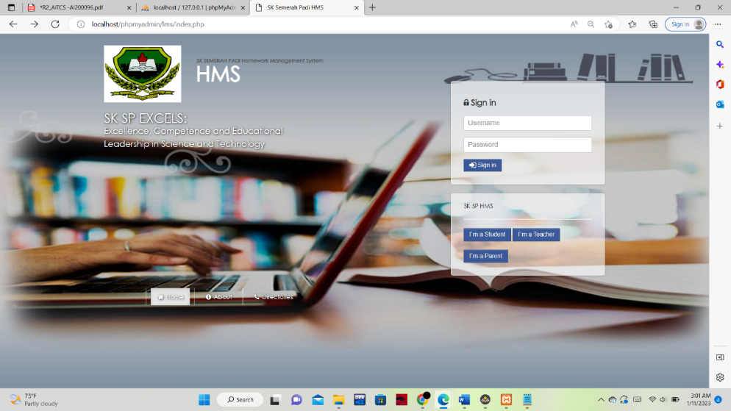

Interface register

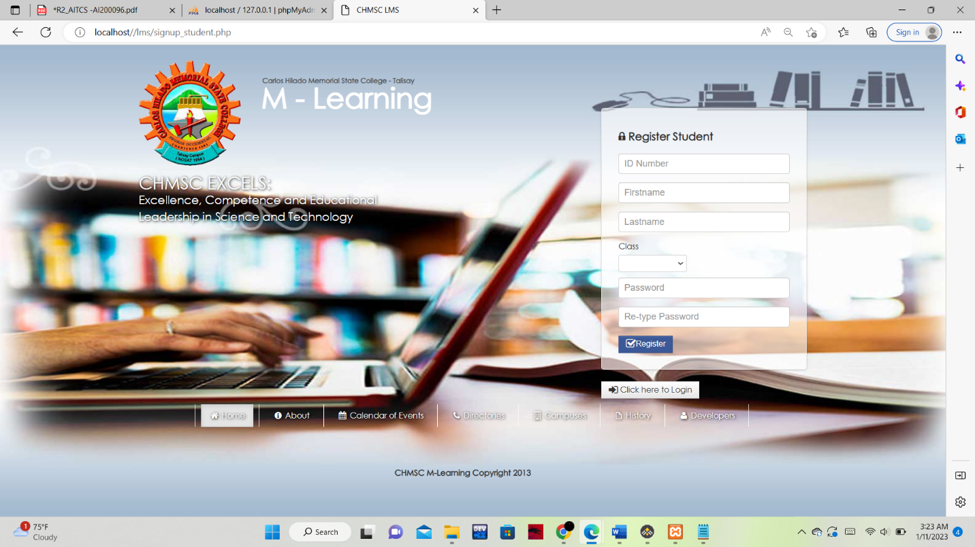

Figure .: Wireframe for the other module

Figure 8.1: Wireframes manage user information

Figure 8.2: Wireframes manage homework

Figure 8.3: Wireframes submit assignment

Figure 8.4: Wireframes grade homework Figure 8.5 Wireframes generate report

## Chapter Summary

In conclusion, this chapter concludes all the design through some related diagram. In system requirements analysis, it is divided into two type namely functional requirements and non-functional requirements of the system. Design diagrams such as Use Case Diagrams and Sequence diagram have been sketched to know the flow of the system.

# REFERENCES

[1] Ashari, Z. M., Ngadiman, A. A., Zainudin, N. F., & Jumaat, N. F. (2018). The Relationship between Knowledge and Attitude towards Technology Gadget Usage with Students' Socio-Emotions Development. International Journal of Interactive Mobile Technologies, 12(7).

[2] Author UTHM academic online resources Global Learning System UTHM. (2019). Author UTHM Academic Online Resources. https://author.uthm.edu.my/

[3] MAKLUMAT SEKOLAH. (2009, December 11). SELAMAT DATANG KE LAMAN BLOG SK SEMERAH PADI; SELAMAT DATANG KE LAMAN BLOG SK SEMERAH PADI. https://sksemerahpadi.wordpress.com/maklumat-sekolah/

[4] Satrom, B. (2018). Choosing the Right JavaScript Framework for Your Next Web Application. Prog./Kendo UI, 34.

[5] Chinnathambi, K. (2018). Learning react: A hands-on guide to building web applications using react and Redux. Addison-Wesley.

[6] Brandon, D. (2008). Software engineering for modern web applications: Methodologies and technologies. IGI Global (701 E. Chocolate Avenue, Hershey, Pennsylvania, 17033, USA).

[7] Serhan, D. (2019). Web-Based Homework Systems: Students' Perceptions of Course Interaction and Learning in Mathematics. International Journal on Social and Education Sciences, 1(2), 57-62.

[8] Get the Classroom app - Classroom Help. (2022). Google.com. <https://support.google.com/edu/classroom/answer/6118412?hl=en>

‌[9] Froglearn. FrogLearn | Learning Platform &amp; VLE. (n.d.). Retrieved December 27, 2022,

from https://www.frogeducation.com/edu/ourproduct/froglearn

[10] Phoong, S. Y., Phoong, S. W., &amp; Phoong, K. H. (2020, February). (PDF) the effectiveness

of Frog Virtual Learning Environment in ... Retrieved December 27, 2022, from

<https://www.researchgate.net/publication/340477757_The_Effectiveness_of_>Frog_Virt

ual_Learning_Environment_in_Teaching_and_Learning_Mathematics

[11] Zainal, M. R. B. (2018, December 20). Teknologi Pendidikan. MOE. Retrieved December

27, 2022, from

https://www.moe.gov.my/index.php?option=com_content&amp;view=article&amp;id=4035%3A

btek

[12] School. (n.d.). Retrieved December 27, 2022, fromhttps://www.frogasia.com/school

[13] Google. (n.d.). Classroom Management Tools & Resources. Google for Education. Retrieved December 27, 2022, from [https://edu.google.com/workspace-for-education/classroom/](https://edu.google.com/workspace-for-education/classroom/%20)

[14] Albashtawi, A., & Al Bataineh, K. (2020). The effectiveness of google classroom among EFL students in Jordan: An innovative teaching and learning online platform. International Journal of Emerging Technologies in Learning (iJET), 15(11), 78-88.

[15] About Classroom - Classroom Help. (2022). Google.com. https://support.google.com/edu/classroom/answer/6020279?hl=en

‌[16] Google. (n.d.). Sign in. Google Accounts. Retrieved December 27, 2022, from [https://classroom.google.com/u/0/](https://classroom.google.com/u/0/%20)

[17] Author UTHM academic online resources Global Learning System UTHM. (2019). Author UTHM Academic Online Resources. https://author.uthm.edu.my/#

[18] Despa, M. L. (2014). Comparative study on software development methodologies. Database Systems Journal, 5(3), 37-56.

[19] Granulo, A., & Tanović, A. (2019, November). Comparison of SCRUM and KANBAN in the Learning Management System implementation process. In 2019 27th Telecommunications Forum (TELFOR) (pp. 1-4). IEEE.

[20] Al-Saqqa, S., Sawalha, S., & AbdelNabi, H. (2020). Agile Software Development: Methodologies and Trends. International Journal of Interactive Mobile Technologies, 14(11).

[21] Melnyk, K. V., Hlushko, V. N., & Borysova, N. V. (2020). Decision support technology for sprint planning. Radio Electronics, Computer Science, Control, (1), 135-145.

[22] Li, T. (2021). A Detailed Process for Aviation Systems Requirements Analysis and Definition via Model-Based Approach. In Complex Systems Design & Management (pp. 463-463). Springer, Cham.

[23] Gharib, M. (2020). Dealing with Non-functional Requirements, the Case of Information Quality Requirements: Experience Report. In iStar (pp. 25-30).

[24] Tilley, S. (2019). Systems analysis and design. Cengage Learning.

[25] Fauzan, R., Siahaan, D., Rochimah, S., & Triandini, E. (2021). A different

approach on automated use case diagram semantic assessment. International

Journal of Intelligent Engineering and Systems, 14(1), 496-505.

[26] IBM Documentation. (2021, March 9). Ibm.com. https://www.ibm.com/docs/en/elm/6.0.3?topic=cases-use-case-specification-outline

‌[27] Kulkarni, R. N., & Prasad, P. P. R. (2021). Abstraction of UML Class Diagram from the Input Java Program. International Journal Of Advanced Networking And Applications, 12(4), 4644-4649.

APPENDIX  **(Gantt Chart*.***

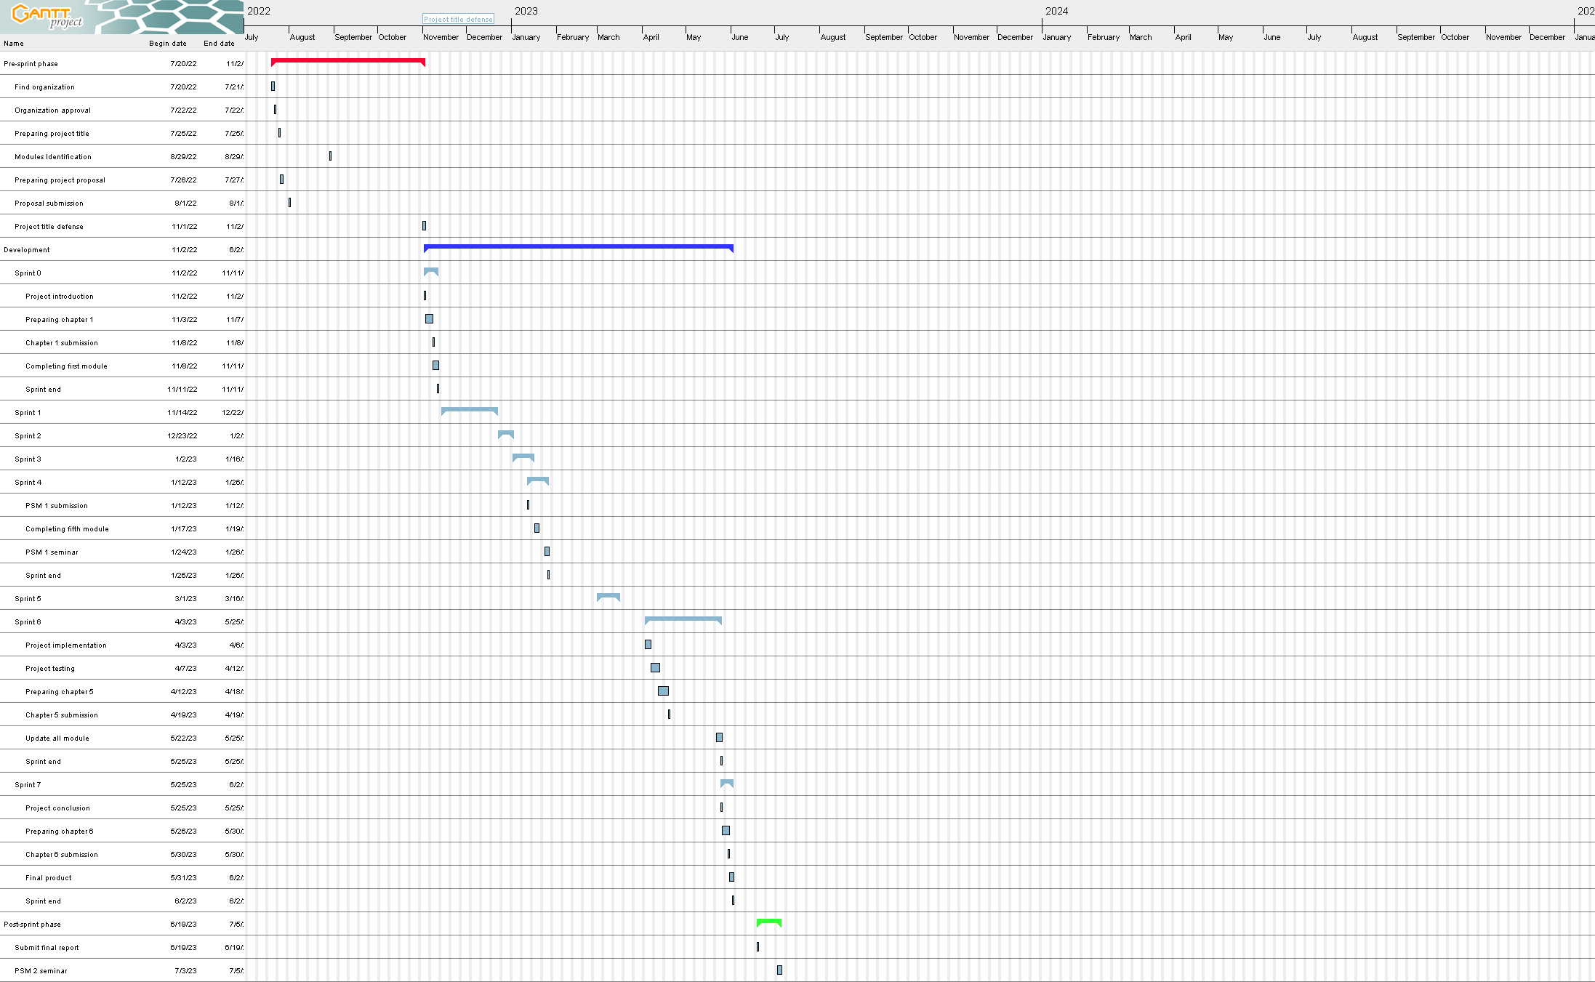

Figure 1: Gantt Chart

APPENDIX **(Use Case Specification*.***

* + - 1. Use Case Specification for Login

|  |  |  |  |  |  |  |
| --- | --- | --- | --- | --- | --- | --- |
| **History Log** | 1.0.0 | 1. Create initial use case | | | | |
|  | 1.0.1 | 1. Fixed alternative flow in normal flow | | | | |
| **Version** | 1.0.1 | | | | | |
| **Use Case ID** | UC-1 | | | | | |
| **Use Case Name** | Login | | | | | |
| **Created By** | Raihan Afiqah | | | **Updated By** | Raihan Afiqah | |
| **Date Created** | 8 January 2022 | | | **Last Revision Date** | 8 January 2022 | |
| **Actors** | Admin, Teacher, Parent, Student | | | | | |
| **Description** | Login of user into the system | | | | | |
| **Preconditions** | Users need to insert username and password | | | | | |
| **Post conditions** | User will be redirected to home page | | | | | |
| **Normal Flow** | 1. Verify the users    * + 1. Users need to insert valid username and password        2. System redirects users to the homepage        3. If the user is new user, they need to ask user to register them first | | | | | |
| **Alternative flow** | NONE | | | | | |
| **Exceptions** | **E.1 Fail to login**   1. System pop up to inform users that invalid user and password 2. System will pop up to input correct username and password | | | | | |
| **Related requirement** | **ID** | | **Requirement** | | | **Priority** |
| FR01-01 | | The system should allow user to login into the system using registered username and password. | | | Basic |
|  | FR01-02 | | The system should allow only registered user to login into the system | | | Excitement |
|  | FR01-03 | | The system should redirect user to respective home page upon successful login | | | Performance |
|  | CR01-01 | | The system shall not allow unregistered user to login into system | | | Basic |
| **Activity Diagram** | | | | | | |
| Figure 1.1: Activity diagram for use case login | | | | | | |
| **Sequence Diagram** | | | | | | |
| Figure 1.2: Sequence diagram for use case login | | | | | | |

1. Use Case Specification for Register user

|  |  |  |  |  |  |  |
| --- | --- | --- | --- | --- | --- | --- |
| **History Log** | 1.0.0 | * + - 1. Create initial use case | | | | |
|  | 1.0.1 | 1. Fixed alternative flow in normal flow | | | | |
| **Version** | 1.0.1 | | | | | |
| **Use Case ID** | UC-2 | | | | | |
| **Use Case Name** | Register user | | | | | |
| **Created By** | Raihan Afiqah | | | **Updated By** | Raihan Afiqah | |
| **Date Created** | 8 January 2022 | | | **Last Revision Date** | 8 January 2022 | |
| **Actors** | Admin | | | | | |
| **Description** | Register user into the system | | | | | |
| **Preconditions** | Admin need to login into the system | | | | | |
| **Post conditions** | Admin will be redirected to user view detail page | | | | | |
| **Normal Flow** | 1. User Registration   1. Admin will input all details for new user   * + - 1. System will store into the database       2. If the registration is successful, the system will redirect to users view detail page | | | | | |
| **Alternative flow** | NONE | | | | | |
| **Exceptions** | **E.1 Fail to register**  1. System pop up to inform user registration fail  2. System will pop up to input correct detail | | | | | |
| **Related requirement** | **ID** | | **Requirement** | | | **Priority** |
| FR02-01 | | The system should allow admin to register new user into the system | | | Basic |
|  | FR02-02 | | The system should be able to store the registered user information in the database | | | Basic |
| **Activity Diagram** | | | | | | |
| Figure 2.1:Activity diagram for use case register user | | | | | | |
| **Sequence Diagram** | | | | | | |
| Figure 2.2: Sequence diagram for use case register user | | | | | | |

1. Use Case Specification for Manage user information

|  |  |  |  |  |  |  |
| --- | --- | --- | --- | --- | --- | --- |
| **History Log** | 1.0.0 | * + - 1. Create initial use case | | | | |
|  | 1.0.1 | 1. Fixed alternative flow in normal flow | | | | |
| **Version** | 1.0.1 | | | | | |
| **Use Case ID** | UC-3 | | | | | |
| **Use Case Name** | Manage user information | | | | | |
| **Created By** | Raihan Afiqah | | | **Updated By** | Raihan Afiqah | |
| **Date Created** | 8 January 2022 | | | **Last Revision Date** | 8 January 2022 | |
| **Actors** | Admin | | | | | |
| **Description** | Add, edit, and delete user information | | | | | |
| **Preconditions** | Admin need to login into the system | | | | | |
| **Post conditions** | System will redirect user to user view detail page | | | | | |
| **Normal Flow** | 1. Add user detail   1. Admin click “add” button  2. Admin enter all the user details  3. Admin click “submit” button  4. System add the information  2.0 Edit user detail  1. Admin click “edit” button  2. Admin update the user details  3. Admin click “submit” button  4. System edit the user information  3.0 Delete user detail  1. Admin click “delete” button  2. System prompt confirmation message  3. Admin click “delete” button  4. System delete user information | | | | | |
| **Alternative flow** | NONE | | | | | |
| **Exceptions** | **E.1 Fail to add user detail**  1. System pop up to inform user detail addition fail  2. System will pop up to input correct detail  **E.2 Fail to edit user detail**  1. System pop up to inform update user detail fail  2. System will pop up to try again  **E.3 Fail to delete user detail**  1. System pop up to inform user detail deletion fail  2. System will pop up to try again | | | | | |
| **Related requirement** | **ID** | | **Requirement** | | | **Priority** |
| FR03-01 | | The system should allow admin to register new user into the system | | | Basic |
|  | FR03-02 | | The system should be able to store the registered user information in the database | | | Basic |
| **Activity Diagram** | | | | | | |
| Figure 3.1:Activity diagram for use case manage user information | | | | | | |
| **Sequence Diagram** | | | | | | |
| Figure 3.2: Sequence diagram for use case Manage user information | | | | | | |

# 

1. Use Case Specification for Manage homework

|  |  |  |  |  |  |  |
| --- | --- | --- | --- | --- | --- | --- |
| **History Log** | 1.0.0 | * + - 1. Create initial use case | | | | |
|  | 1.0.1 | 1. Fixed alternative flow in normal flow | | | | |
| **Version** | 1.0.1 | | | | | |
| **Use Case ID** | UC-4 | | | | | |
| **Use Case Name** | Manage homework | | | | | |
| **Created By** | Raihan Afiqah | | | **Updated By** | Raihan Afiqah | |
| **Date Created** | 8 January 2022 | | | **Last Revision Date** | 8 January 2022 | |
| **Actors** | Teacher | | | | | |
| **Description** | Add, edit, and delete homework | | | | | |
| **Preconditions** | Teacher needs to login into the system | | | | | |
| **Post conditions** | System will redirect user to homework view detail page | | | | | |
| **Normal Flow** | 1. Add homework detail   1. Teacher click “add” button  2. Teacher enter all the homework details  3. Teacher click “submit” button  4. System add homework  2.0 Edit homework detail  1. Teacher click “edit” button  2. Teacher update the homework details  3. Teacher click “submit” button  4. System edit the homework  3.0 Delete homework detail  1. Teacher click “delete” button  2. System prompt confirmation message  3. Teacher click “delete” button  4. System delete homework | | | | | |
| **Alternative flow** | NONE | | | | | |
| **Exceptions** | **E.1 Fail to add homework**  1. System pop up to inform homework addition fail  2. System will pop up to input correct detail  **E.2 Fail to edit homework**  1. System pop up to inform the update homework fail  2. System will pop up Try again  **E.3 Fail to delete homework**  1. System pop up to inform user homework deletion fail  2. System will pop up Try again | | | | | |
| **Related requirement** | **ID** | | **Requirement** | | | **Priority** |
| FR04-01 | | The system should allow teacher to add homework | | | Basic |
|  | FR04-02 | | The system should allow teacher to edit homework | | | Basic |
|  | FR04-03 | | The system should allow teacher to delete homework | | | Basic |
| **Activity Diagram** | | | | | | |
| Figure 4.1: Activity diagram for use case Manage homework | | | | | | |
| **Sequence Diagram** | | | | | | |
| Figure 4.2: Sequence diagram for use case Manage homework | | | | | | |

1. Use Case Specification for Submit homework

|  |  |  |  |  |  |  |
| --- | --- | --- | --- | --- | --- | --- |
| **History Log** | 1.0.0 | * + - 1. Create initial use case | | | | |
|  | 1.0.1 | 1. Fixed alternative flow in normal flow | | | | |
| **Version** | 1.0.1 | | | | | |
| **Use Case ID** | UC-5 | | | | | |
| **Use Case Name** | Submit homework | | | | | |
| **Created By** | Raihan Afiqah | | | **Updated By** | Raihan Afiqah | |
| **Date Created** | 8 January 2022 | | | **Last Revision Date** | 8 January 2022 | |
| **Actors** | Student | | | | | |
| **Description** | Submit and delete submitted homework | | | | | |
| **Preconditions** | Student needs to login into the system | | | | | |
| **Post conditions** | System will redirect user to submit homework view page | | | | | |
| **Normal Flow** | 1. Add homework detail   1. Student click “add” button  2. Student upload the homework  3. System add homework  2.0 Delete homework detail  1. Student click “delete” button  2. System prompt confirmation message  3. Student click “delete” button  4. System delete submitted homework | | | | | |
| **Alternative flow** | NONE | | | | | |
| **Exceptions** | **E.1 Fail to add homework**  1. System pop up to inform homework addition fail  2. System will pop up to input correct detail  **E.2 Fail to delete submitted homework**  1. System pop up to inform user homework deletion fail  2. System will pop up Try again | | | | | |
| **Related requirement** | **ID** | | **Requirement** | | | **Priority** |
| FR05-01 | | The system should allow student to submit homework | | | Basic |
|  | FR05-02 | | The system should be able to allow student to delete submitted homework | | | Basic |
| **Activity Diagram** | | | | | | |
| Figure 5.1: Activity diagram for use case Submit homework | | | | | | |
| **Sequence Diagram** | | | | | | |
| Diagram, engineering drawing  Description automatically generated  Figure 5.2: Sequence diagram for use case Submit homework | | | | | | |

1. Use Case Specification for Record grade

|  |  |  |  |  |  |  |
| --- | --- | --- | --- | --- | --- | --- |
| **History Log** | 1.0.0 | * + - 1. Create initial use case | | | | |
|  | 1.0.1 | 1. Fixed alternative flow in normal flow | | | | |
| **Version** | 1.0.1 | | | | | |
| **Use Case ID** | UC-6 | | | | | |
| **Use Case Name** | Record grade | | | | | |
| **Created By** | Raihan Afiqah | | | **Updated By** | Raihan Afiqah | |
| **Date Created** | 8 January 2022 | | | **Last Revision Date** | 8 January 2022 | |
| **Actors** | Teacher, Student, Parent | | | | | |
| **Description** | Add, edit, delete, and view grade | | | | | |
| **Preconditions** | Users need to login into the system | | | | | |
| **Post conditions** | System will redirect user to grade view page | | | | | |
| **Normal Flow** | 1. Add grade   1. Teacher click “add” button  2. Teacher enter grade  3. Teacher click “submit” button  4. System add the grade  2.0 Edit grade  1. Teacher click “edit” button  2. Teacher update the grade  3. Teacher click “submit” button  4. System edit the grade  3.0 Delete grade  1. Teacher click “delete” button  2. System prompt confirmation message  3. Teacher click “delete” button  4. System delete grade  4.0 View grade  1. User click view grade  2. System redirect user to grade view page  3. Choose year  3. System display grade | | | | | |
| **Alternative flow** | NONE | | | | | |
| **Exceptions** | **E.1 Fail to add grade**  1. System pop up to inform grade addition fail  2. System will pop up Try again  **E.2 Fail to edit grade**  1. System pop up to inform update grade fail  2. System will pop up Try again  **E.3 Fail to delete grade**  1. System pop up to inform grade deletion fail  2. System will pop up Try again | | | | | |
| **Related requirement** | **ID** | | **Requirement** | | | **Priority** |
| FR06-01 | | The system should allow teacher to add grade | | | Basic |
|  | FR06-02 | | The system should allow teacher to edit grade | | | Basic |
|  | FR06-03 | | The system should allow teacher to delete grade | | | Basic |
|  | FR06-04 | | The system should allow student and parent to view grade | | | Basic |
| **Activity Diagram** | | | | | | |
| Figure 6.1: Activity diagram for use case Record grade | | | | | | |
| **Sequence Diagram** | | | | | | |
| Figure 6.2: Sequence diagram for use case record grade | | | | | | |

1. Use Case Specification for Generate report

|  |  |  |  |  |  |  |
| --- | --- | --- | --- | --- | --- | --- |
| **History Log** | 1.0.0 | * + - 1. Create initial use case | | | | |
|  | 1.0.1 | 1. Fixed alternative flow in normal flow | | | | |
| **Version** | 1.0.1 | | | | | |
| **Use Case ID** | UC-6 | | | | | |
| **Use Case Name** | Generate report | | | | | |
| **Created By** | Raihan Afiqah | | | **Updated By** | Raihan Afiqah | |
| **Date Created** | 8 January 2022 | | | **Last Revision Date** | 8 January 2022 | |
| **Actors** | Teacher, Student, Parent | | | | | |
| **Description** | To generate grade report | | | | | |
| **Preconditions** | Users need to login into the system | | | | | |
| **Post conditions** | System will redirect user to report view page | | | | | |
| **Normal Flow** | 1. Generate report   1. Select Report option  2. Choose year  3. System will generate the grade report | | | | | |
| **Alternative flow** | NONE | | | | | |
| **Exceptions** | **E.1 No grade added for the year**  1. The report will not display  **E.2 Fail to generate report**  1. System pop up to inform report cannot be generated  2. System will pop up Try again | | | | | |
| **Related requirement** | **ID** | | **Requirement** | | | **Priority** |
| FR07-01 | | The system should allow teacher, parent, and student to generate report | | | Basic |
| **Activity Diagram** | | | | | | |
| Figure 7.1: Activity diagram for use case Generate report | | | | | | |
| **Sequence Diagram** | | | | | | |
| Figure 7.2: Sequence diagram for use case Generate report | | | | | | |